Termite Nuclei Dissociation and FACS Sorting
02/06/2023-06/06/2023

Experimental Overview
Goals:
- Dissociate a decent number of nuclei from termites.
- Remove termite debris from dissociated nuclei.
- Achieve a concentration of nuclei appropriate for 10x Genomics sc sequencing ( approx 700-1200 cells/uL)

Method:
- Nuclei dissociation of termite nuclei using homogenisation and resuspension buffer solutions, grinding, centrifugation and straining.
- FACS sorting using DAPI and the BD FACSAria III to collect nuclei and remove debris.

Results:
- Current homogenisation and resuspension buffer solutions, grinding, centrifugation and straining protocol dissociates nuclei from termites.
- FACS sorting with the BD FACSAria III collected 100K DAPI stained nuclei per run, from a sample containing 6-7 termites, and removed debris from nuclei. Resulting FACS plot looks similar to the plot of single nuclei from Drosophila tissues.
- Concentration of nuclei was achieved by centrifugation.

Below I will briefly outline the protocol we used, and our results, including the FACS plots and images of nuclei under epifluorescent microscope. Please find our excel lab protocol attached to the email.

- Nuclei Dissociation
Twelve N. walkeri soldiers and twelve workers were placed on a dissection dish and were cut into small pieces using tweezers and scissors. Approximately six termites (soldiers and workers were moved to separate tubes) where each moved into one 1.5-mL tube containing 1000 μL of chilled homogenization buffer (Nuclease Free water, 250 mM Sucrose (nuclease free), 10 mM Tris (pH 8.0), 25 mM KCl, 5 mM MgCl2, 0.1% Triton-x 100 and 0.1 mM DTT). The tissue was then homogenized using a pellet pestle, by twisting the pestle approximately 20 times. The nuclei were centrifuged at 1000g for 10 min at 4 °C, and the supernatant was discarded. The pellet was then resuspended in 1000 μL of resuspension buffer (PBS and 0.5% BSA). The nuclei were then strained using 100 and 35 μm cell strainers (see Result 1). After the previous two steps, and after FACS sorting (see Result 2), 10 μL of the nuclei was stained with DAPI (1:1000) and visualized under an epifluorescent microscope. Images of the cells were taken using an Iphone (1), and microscope in the DAPI (2) and brightfield (3) channels.

- FACS Sorting
FACS sorting was performed on the BD FACSAria III. Approximately 100 μL of nuclei suspension was run as an unstained control (see Result 3). DAPI was added (1:1000) to the remaining nuclei and was captured into a FACS tube containing 50 μL of PBS, excluding debris and doublets, and sorting was run until (1) there was no sample left (Tube 2) or 100K events had occurred (Tube 1, 3 and 4). (see Result 3). Subsequently, the concentration of nuclei was determined with a hemocytometer and counting the number under a 20× objective of an epifluorescence microscope (see Result 2). The nuclei were centrifuged at 1000g for 6 min at 4 °C, and approx. 600 μL of supernatant was discarded. The pellet was resuspended in the remaining supernatant.

Sort Settings:
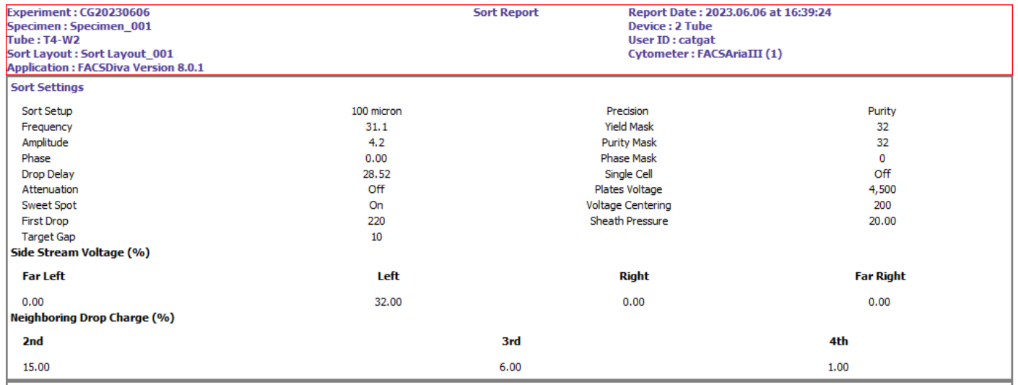

Results

- Nuclei after Straining
  - 100 μm cell strainer
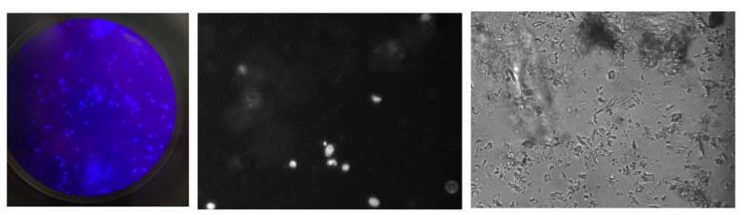

  - 35 μm cell strainer

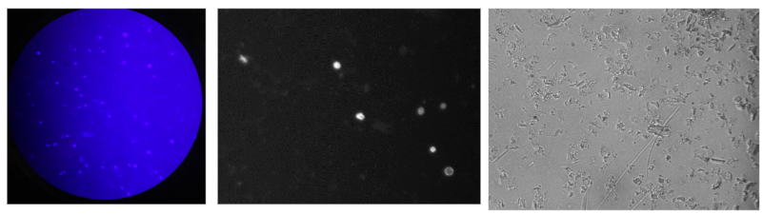

- Nuclei After FACS
  - Before Concentration
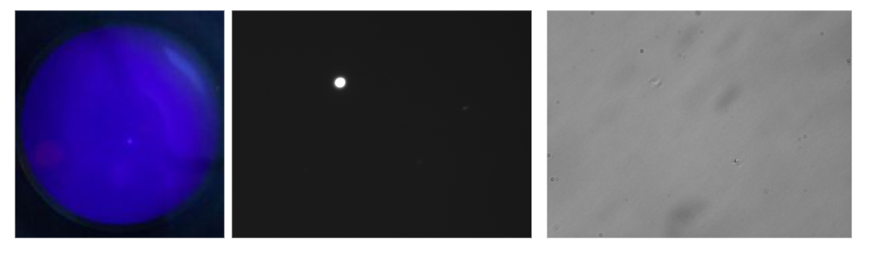
  - After Concentration

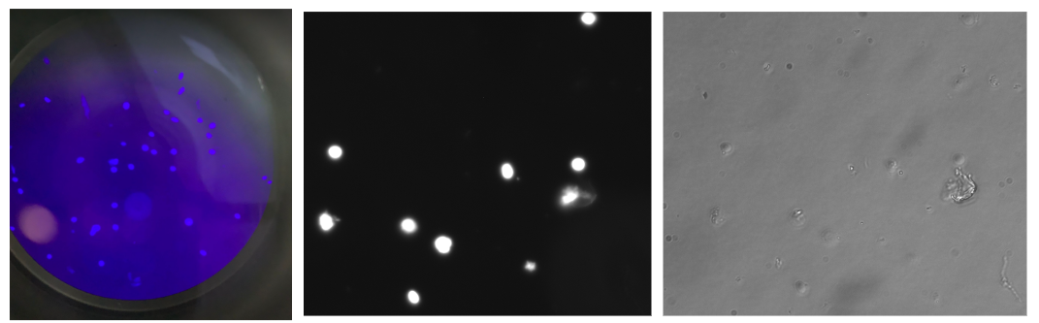

- FACS Plots
  - Unstained Control, 02/06/2023
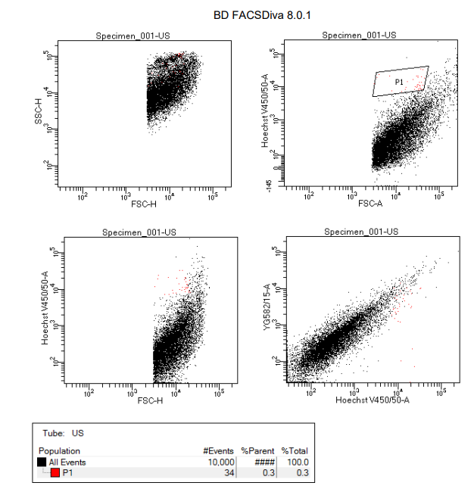

  - Tube 1 (soldiers), 06/06/2023
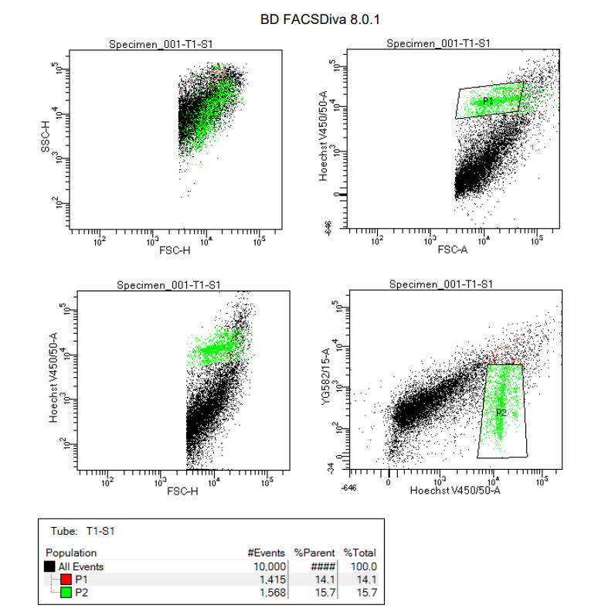

  - Single nuclei from Drosophila tissues
    - Source: https://star-protocols.cell.com/protocols/1669

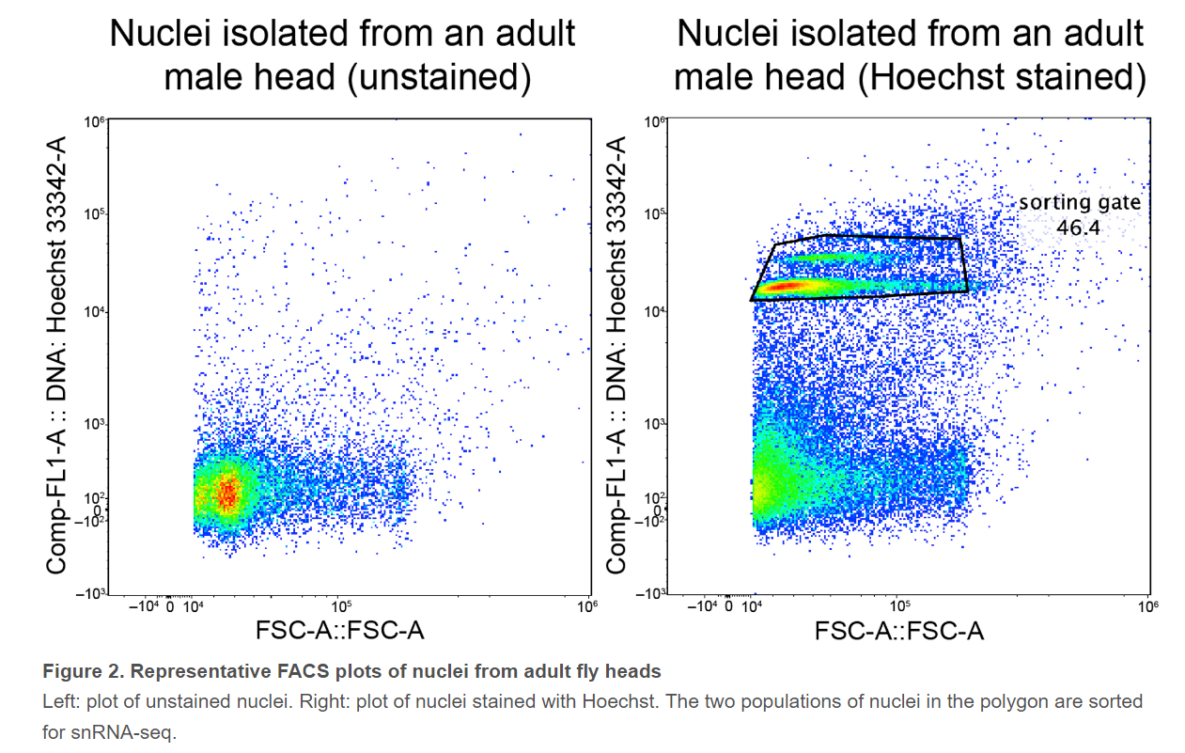

  - Tube 2 (soldiers), 06/06/2023
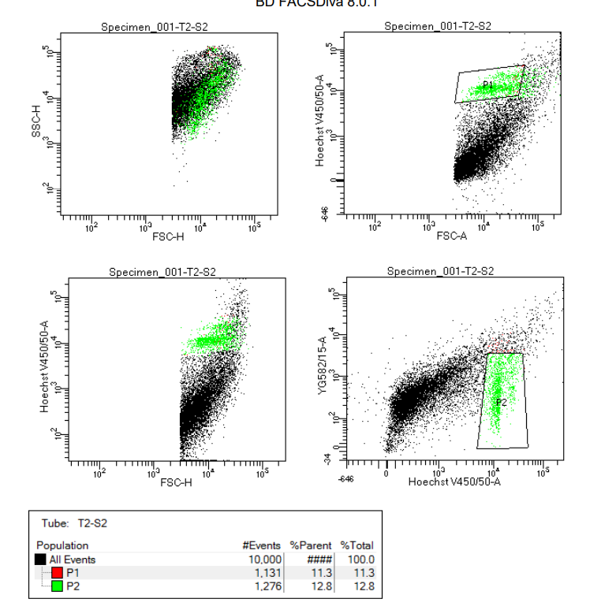

  - Tube 3 (workers), 06/06/2023
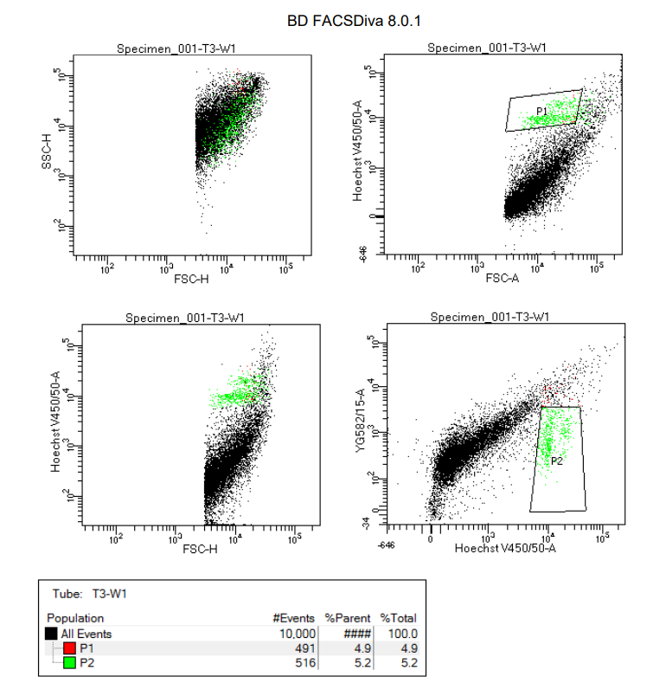

  - Tube 4 (workers) 06/06/2023
